Lister Community School

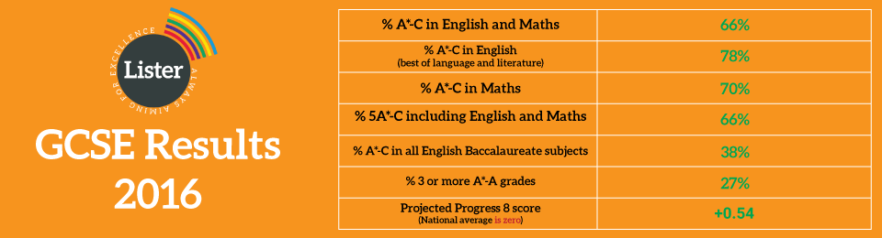
Lister Community School is a large, 11-16 comprehensive school. We are a mixed school that was judged ‘Good’ by Ofsted in 2013 and has just celebrated its 6th consecutive year of record breaking exam results.

We are determined to build on our most recent Ofsted judgement and continue our journey to becoming ‘Outstanding’ in the next two years. Our motto is “always aiming for excellence’. An exceptional school: Our vision is a world class education for young people in Newham.

Lister is embarking on an exciting stage of developing its support services for the school and we are seeking dynamic, professional and high quality individuals to join us in our aim for excellence in all areas.

The school is committed to safeguarding and promoting the welfare of children, and applicants must be willing to undergo child protection screening appropriate to the post including checks with past employers and the Disclosure and Barring Service (DBS).

Teacher of Maths
Main Pay Scale
Required for September 2017 (or earlier if available)
(NQTs are encouraged to apply)

- Do you really believe that non-selective schools can provide as high quality an education as any other school in the country?
- Are you passionate about high quality teaching?
- Do you want to work in a school where they ask every day ‘what is the best way to do this?
- Is your own teaching outstanding, and do you have the skills and knowledge to help others develop their teaching?
- Are you resilient, imaginative, thoughtful, conscientious and determined?
- Do you treat staff and students the way that you expect to be treated yourself?
- Are you continuously on the lookout for examples of outstanding practice which your institution can learn from?
The chance to develop: Work alongside colleagues with high expectations, engage with a broad range of exceptional CPD tailored to your own professional development. Subject specific CPD this year has included Developing Confidence in Algebra (with Durham University), Maths mastery (NCETM) and Enrichment at KS4 (FMSP). Work in a team that provides real potential for career progression.

As part of our continued focus to further develop impact on student progress we are seeking to appoint a passionate Maths Teacher to join our dedicated Maths team. If you think you have the potential to work as an outstanding teacher of Maths then an application form can be downloaded directly from the TES website or Lister’s website: http://www.lister.newham.sch.uk/vacancies/teaching-vacancies/ or by contacting Jackie Young (HR Manager) on 020 8471 3311. Completed applications must be returned to the school at the above address, or by email to: jobs@lister.newham.sch.uk

The school is committed to safeguarding and promoting the welfare of young people and expects all staff to share this commitment. This appointment will be conditional on successful pre-employment and enhanced DBS checks.

Letters of application are required by 9.00am on Wednesday 22nd February 2017.
Interviews: Thursday 27th February 2017 subject to applications.
We will acknowledge receipt of all application forms. If you do not receive acknowledgement, please do not assume that your Application Form has been received. We will only be contacting those candidates who have been selected to progress to the next stage of the process.

