Gainsborough Primary School is a two form, inner city, inclusive school. We believe in our Gainsborough Family, building success together and are very proud of the outcomes for learners at the end of all the Key Stages, where we are consistently at and above National levels. In addition to providing good mainstream education, we offer 14 resourced provision places for children diagnosed with severe autistic spectrum disorder. We have a very skilled team of staff to support all learners.
Currently there are just under 400 pupils on roll, with 40 part time and 8 full time places in nursery. The school is located in a developing area of East London; however Newham ranks in the top 1% of the most deprived boroughs in England. We carefully plan our budget to find the best ways to support all children and to raise attainment. Some of our initiatives include high adult to child ratios, smaller class sizes, focussed interventions and specialist teachers.
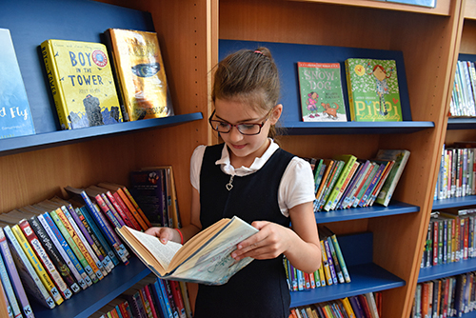
Many children join us mid-year, all talk about the family and nurturing feel of the school. Since 2013 we have gone from strength to strength, appearing in the top 20 of Newham schools for outcomes for learners at key points, e.g. end of EYFS, Phonic Screening and pupil progress from Key Stage 1 to Key Stage 2 and are in the top 10% of schools for pupil progress. We are very proud and want to keep improving. We want every pupil to achieve his or her potential, whatever their starting point; and we aim to create a climate of success for the whole school community.
We believe that to learn well children need to feel safe and secure, and so we provide an orderly, well-disciplined environment. Lessons are carefully planned and structured by teachers so that all children will be able to reach their potential if they work hard. Homework linked to class work is set.
As a school we know that working in partnership with other schools improves the outcomes for pupils in ours. We are part of a mulit-academy trust with Kaizen and Earlham Primary Schools, and Eleanor Smith School (an all through SEMH Specialist School).
At Gainsborough, we have enthusiastic staff who are committed to high standards of learning and behaviour. The school has a wonderful ‘family’ atmosphere that gives children a secure and happy environment in which to learn. We are all passionate that children develop a life-long love of learning and are looking forward to working in partnership with you.
Our aim is to provide exciting, challenging and high quality learning opportunities for all children within a safe and caring learning environment. We value learning through experience; learning core skills in ways that are memorable and enable the children to apply these skills in all aspects of life.
Our curriculum motivates the children to ask questions, see connections between things and enables the children be self-reflective about the world around them. We set learning challenges which lead to high levels of engagement. We constantly strive for better and this means the children achieve the highest possible standards.
We have a Breakfast Club (from 7.30am) and Monday to Friday Club (until 5.30pm) to support working parents and those in full time education. This provision, along with our wide range of after school clubs, enables children to build wider social links in the safe environment of school.

